Robotics
IGCSE Computer Science 0478 | 6.2 | Student booklet
Name: _______________________________ | Date: _____________

This booklet has everything you need for the lesson in one place. Work through it in order:
- Learn sections show the key slides. Read them carefully: they explain the ideas you need for the next task.
- Task sections are where you practise. Each task uses what the slides just before it taught you.
- Most questions are real Cambridge IGCSE exam questions, with the paper shown underneath. Tasks get harder as you go, and Task 6 is an extension.
Do Task 1 from memory before you turn the page.
Task 1 Recall test: automated systems (6.1) [12 marks] closed book
1 Write the letter of the most suitable use next to each sensor. [6]
Sensor | Use (letter) |  | Uses
Acoustic |  | A | Counting the cars that enter a car park
Humidity |  | B | Stopping a robot vacuum cleaner before it hits a chair
Infra-red |  | C | Hearing water dripping from a cracked pipe
Magnetic field |  | D | Refilling an animals' water bowl when it is nearly empty
Level |  | E | Keeping the air in a greenhouse moist enough
Proximity |  | F | Opening automatic doors when a person walks towards them

A farmer has a plough that is an automated system. The plough uses sensors and a microprocessor to maintain a straight line when digging the ground.
2 State what is meant by an automated system. [1]

3 Describe the role of the microprocessor in this process. [3]

0478/13 Oct/Nov 2024 Q5(a), (b)
4 Sensors can be used in an automated system. Give two benefits of using sensors in this type of system. [2]

0478/13 May/June 2024 Q6(b)
Learn What is a robot?
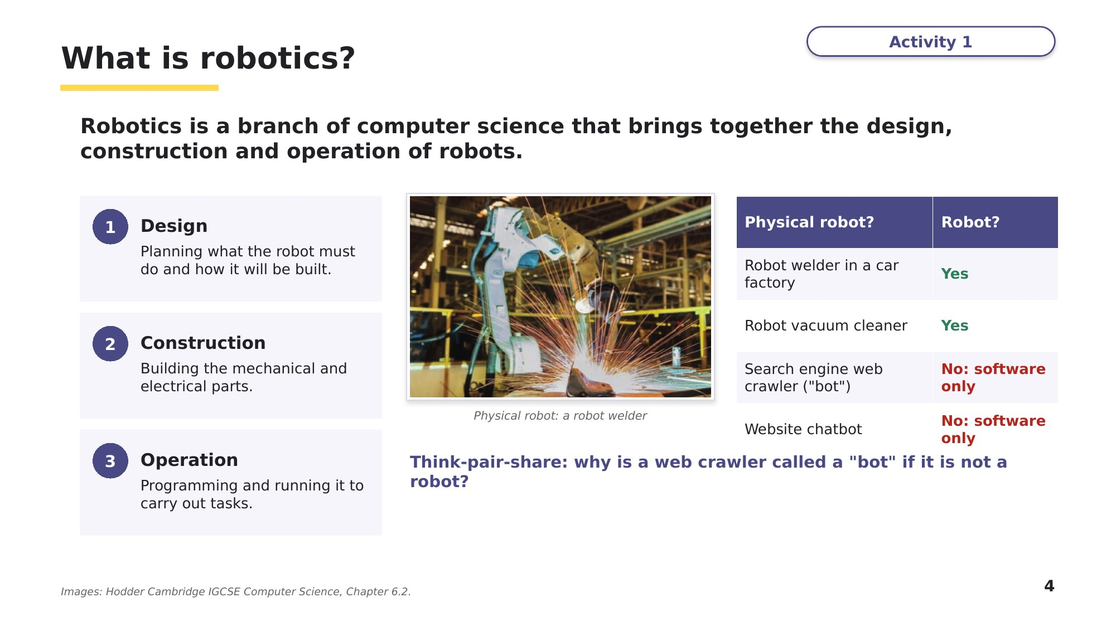
Slide 4 - What is robotics?
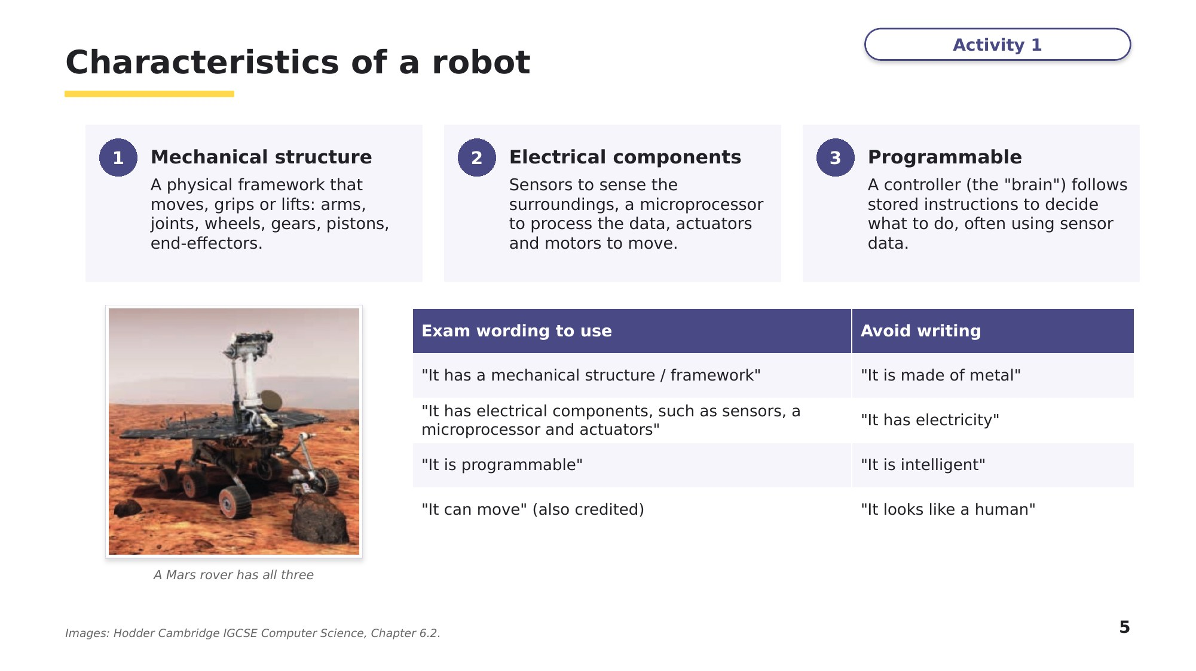
Slide 5 - Characteristics of a robot
Task 2 Robot or not? [14 marks]
(a) Describe what is meant by robotics. [2]

0478/12 Feb/March 2023 Q6(b)
A company uses robots in its factory to manufacture large pieces of furniture.
(b) One characteristic of a robot is that it is programmable. State two other characteristics of a robot. [2]

0478/11 May/June 2023 Q9(a)
(c) Decide whether each device is a robot. Give a reason using the characteristics of a robot. [5]
Device | Robot? (yes / no) | Reason
Autonomous parcel delivery drone
Electric toothbrush
Website chatbot
Robot arm that welds car bodies
Pool-cleaning robot

(d) Draw a line from each description to the correct computer term. [5]
Description |  | Term
No direct human control and has the ability to carry out human activity totally on its own |  | dependent robot
Machine that requires a human interface to operate and allows it to supplement human activities |  | actuator
Branch of computer science that brings together the design, construction and operation of mechanical machines |  | end-effector
Devices attached to a robotic arm which allow it to carry out various tasks |  | autonomous
Device, under the control of a microprocessor, which allows it to operate pumps, wheels, motors and pistons |  | robotics
Hodder IGCSE Computer Science, Activity 6.9 Q2
Learn Robots, AI, and types of robot
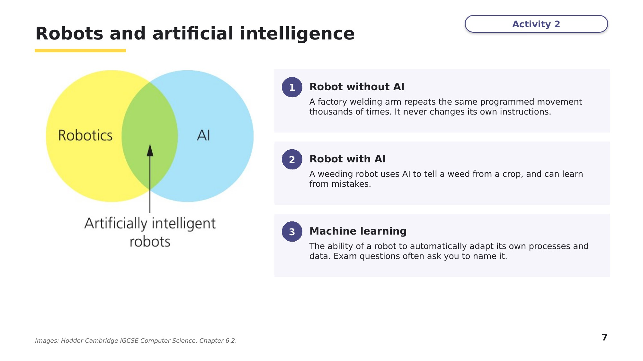
Slide 7 - Robots and artificial intelligence
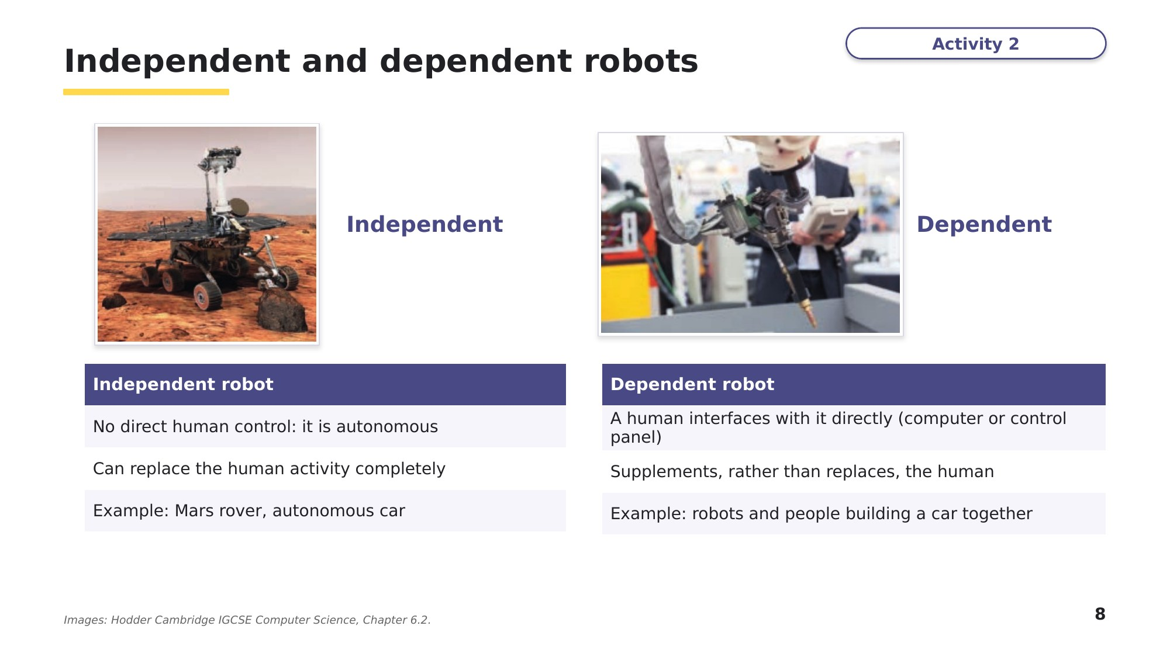
Slide 8 - Independent and dependent robots
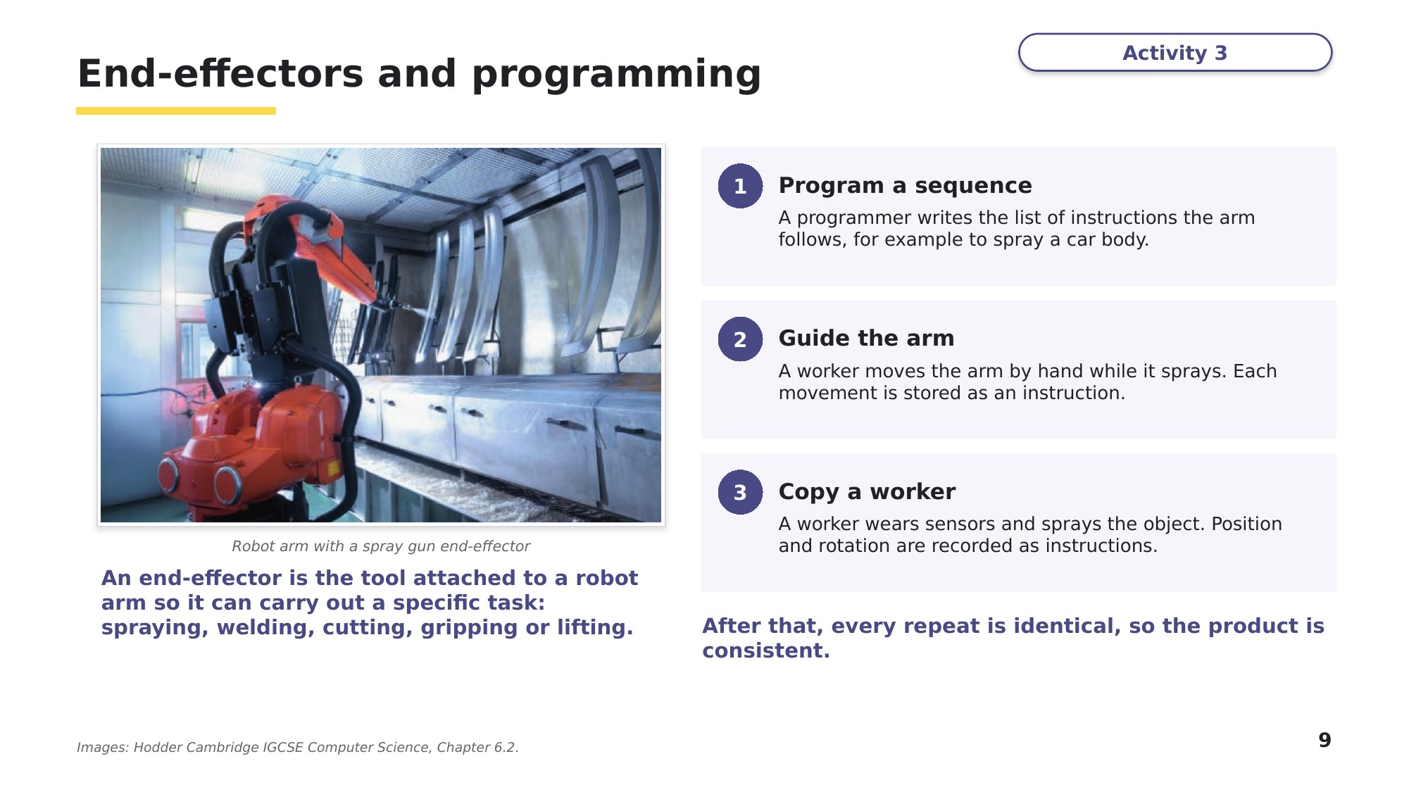
Slide 9 - End-effectors and programming
Task 3 Classify and apply [16 marks]
(a) Classify each robot as independent or dependent, and give a reason. [6]
Robot | Independent or dependent? | Reason
A robot exploring the surface of Mars
A surgical robot controlled by a surgeon at a console
An autonomous vacuum cleaner
A bomb-disposal robot driven with a remote control
A driverless train on a city railway
A robot arm that hands parts to a worker on an assembly line

(b) Name a suitable end-effector for each task. [4]
Task | End-effector
Joining two metal panels of a car body
Painting a car door
Picking up eggs without breaking them
Cutting metal sheets to a high precision

(c) A robot arm needs to spray paint onto car doors. Describe two ways the robot arm could be programmed to do this. [4]

(d) Many robots do not use artificial intelligence. Explain why. [1]

(e) Some robots have the ability to automatically adapt their own processes. State the name of the ability described. [1]

(e): 0478/11 May/June 2025 Q8(e)
Learn Robots that sense and act
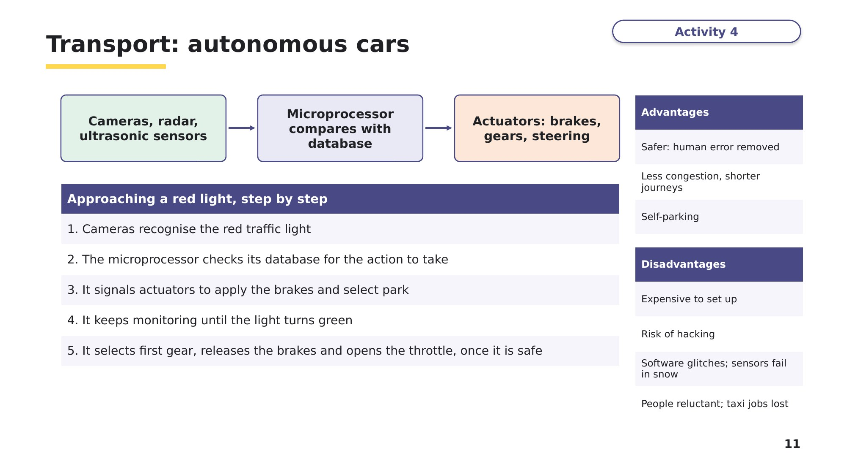
Slide 11 - Transport: autonomous cars
Use the same chain as in 6.1: sensor, microprocessor, actuator, repeat.
Task 4 Exam questions: robots that sense and act [18 marks]
A farmer uses an automated robot to plant seeds in the field.
(a) State what is meant by the robot being automated. [1]

(b) Give three characteristics of a robot. [3]

(c) The robot plants seeds and stops when it reaches a fence. It then turns and continues planting seeds. The robot uses sensors and a microprocessor to know when it reaches a fence. Explain how the robot uses sensors and a microprocessor to know it has reached a fence. [6]

0478/11 May/June 2024 Q8(a)-(c)
A self-driving tractor sows seeds and harvests crops for a farmer. The self-driving tractor moves automatically through the field, turning at each end and stopping when it has finished.
(d)-(f): 0478/12 Feb/March 2024 Q6(a), (b)(ii), (c)
(d) One reason the self-driving tractor is a robot is because it has a mechanical structure that includes wheels, an engine, and a framework. Give one other reason why the self-driving tractor is an example of a robot. [1]

(e) If a person is detected within 3 metres whilst the tractor is moving, it must stop. An infra-red sensor is used for this. Identify one other sensor that the self-driving tractor might use and how it will use the sensor. [2]
Sensor
Use

(f) Explain the drawbacks of a farmer using a self-driving tractor to sow seeds and harvest crops. [3]

Learn Check your Task 4 answers
Only look at this slide once you have finished Task 4. Tick each marking point you included in part (c).
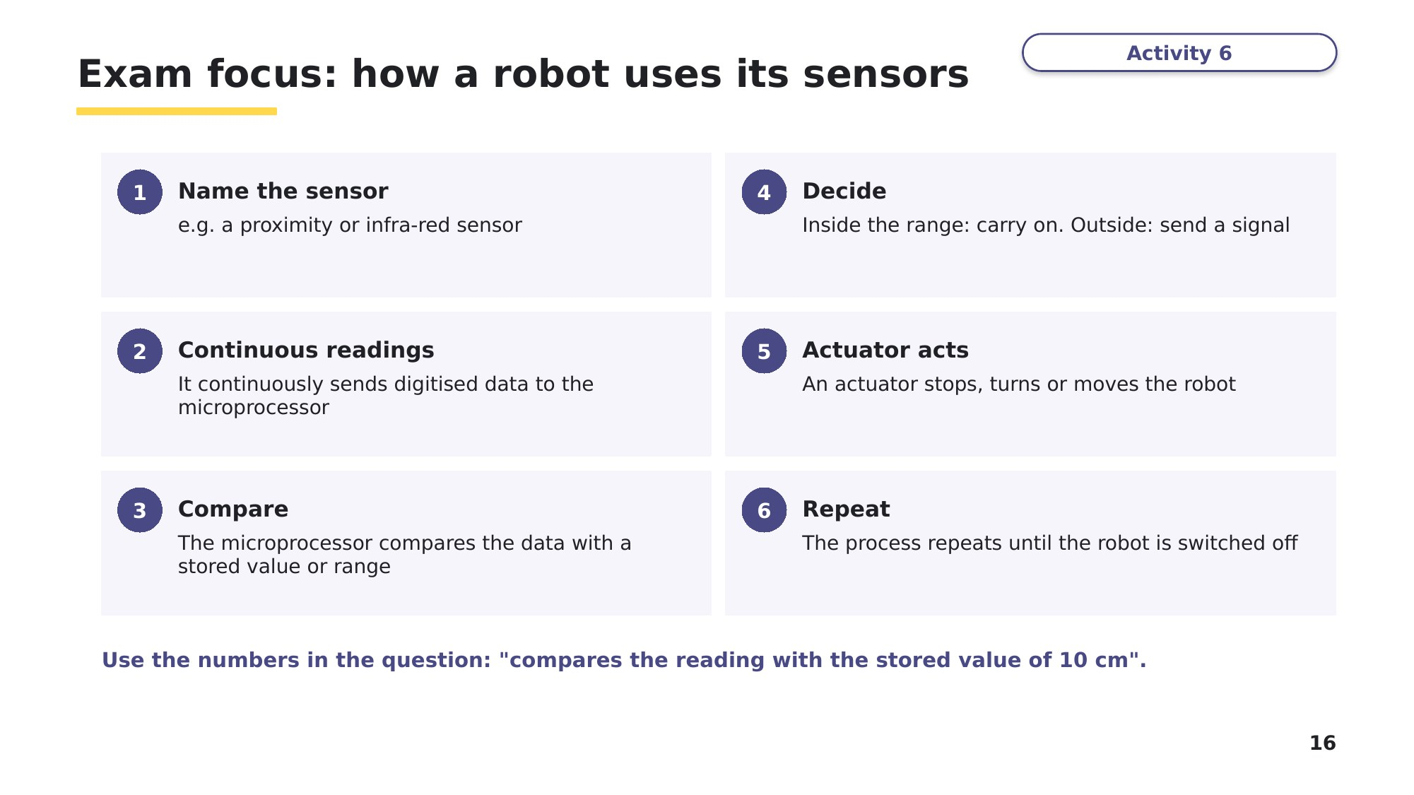
Slide 16 - Exam focus: how a robot uses its sensors
Learn Roles of robots
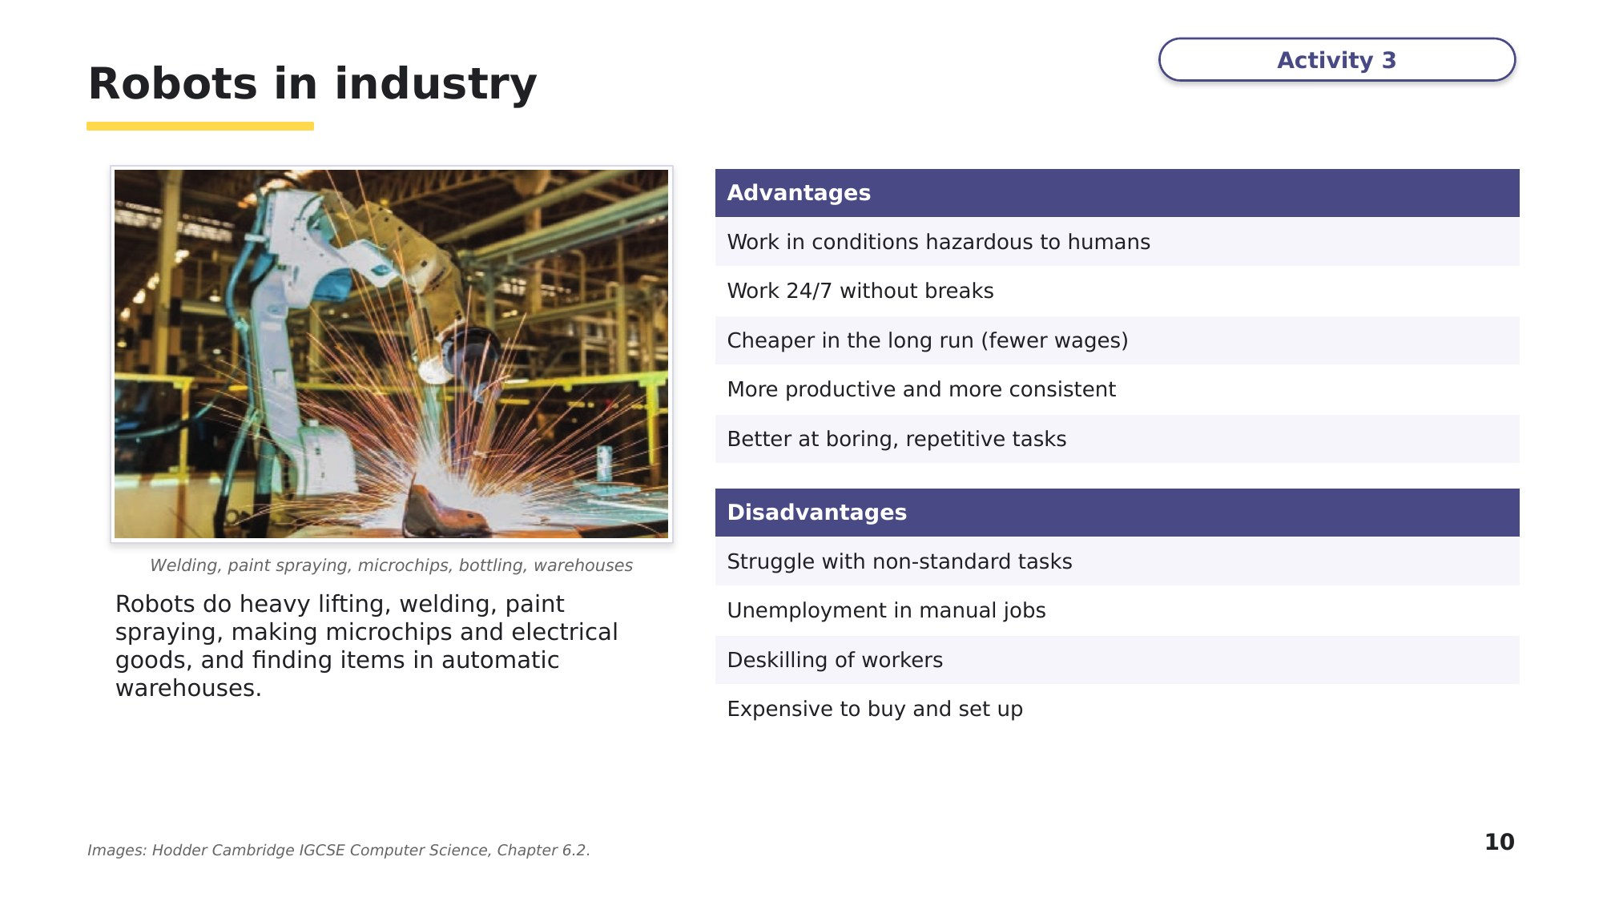
Slide 10 - Robots in industry
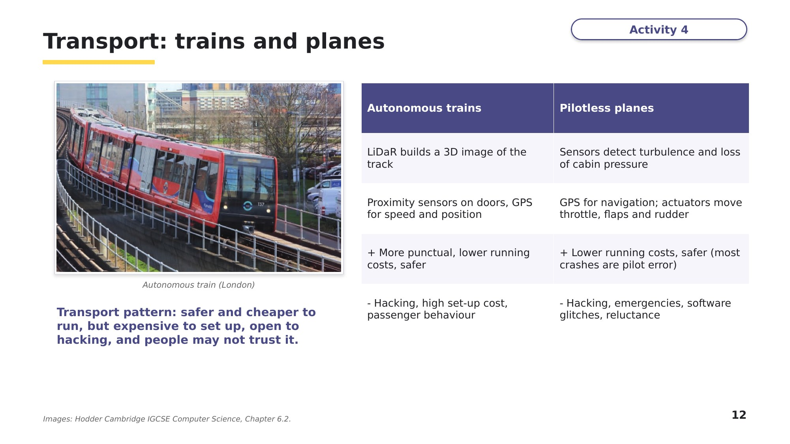
Slide 12 - Transport: trains and planes
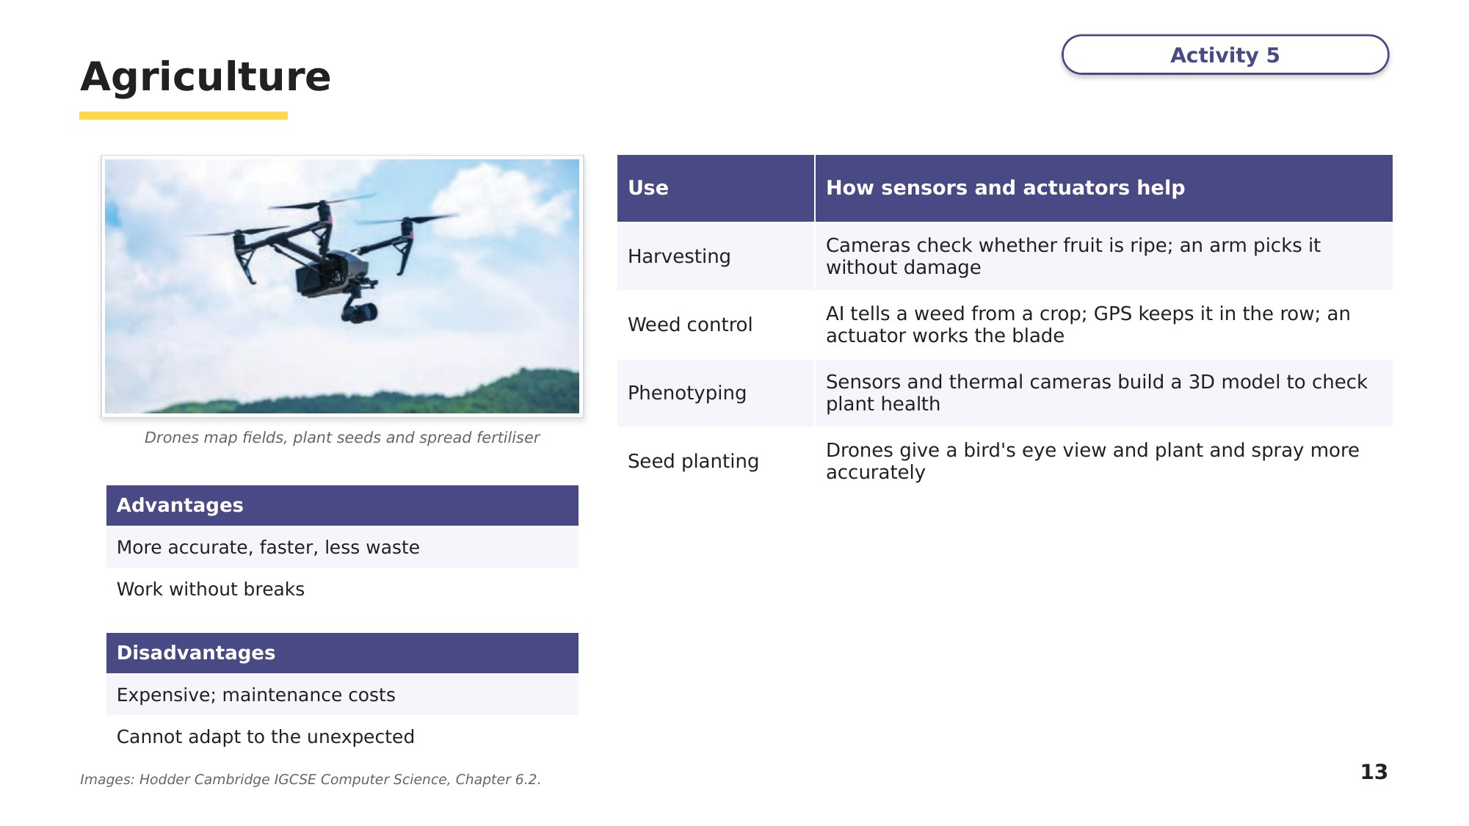
Slide 13 - Agriculture
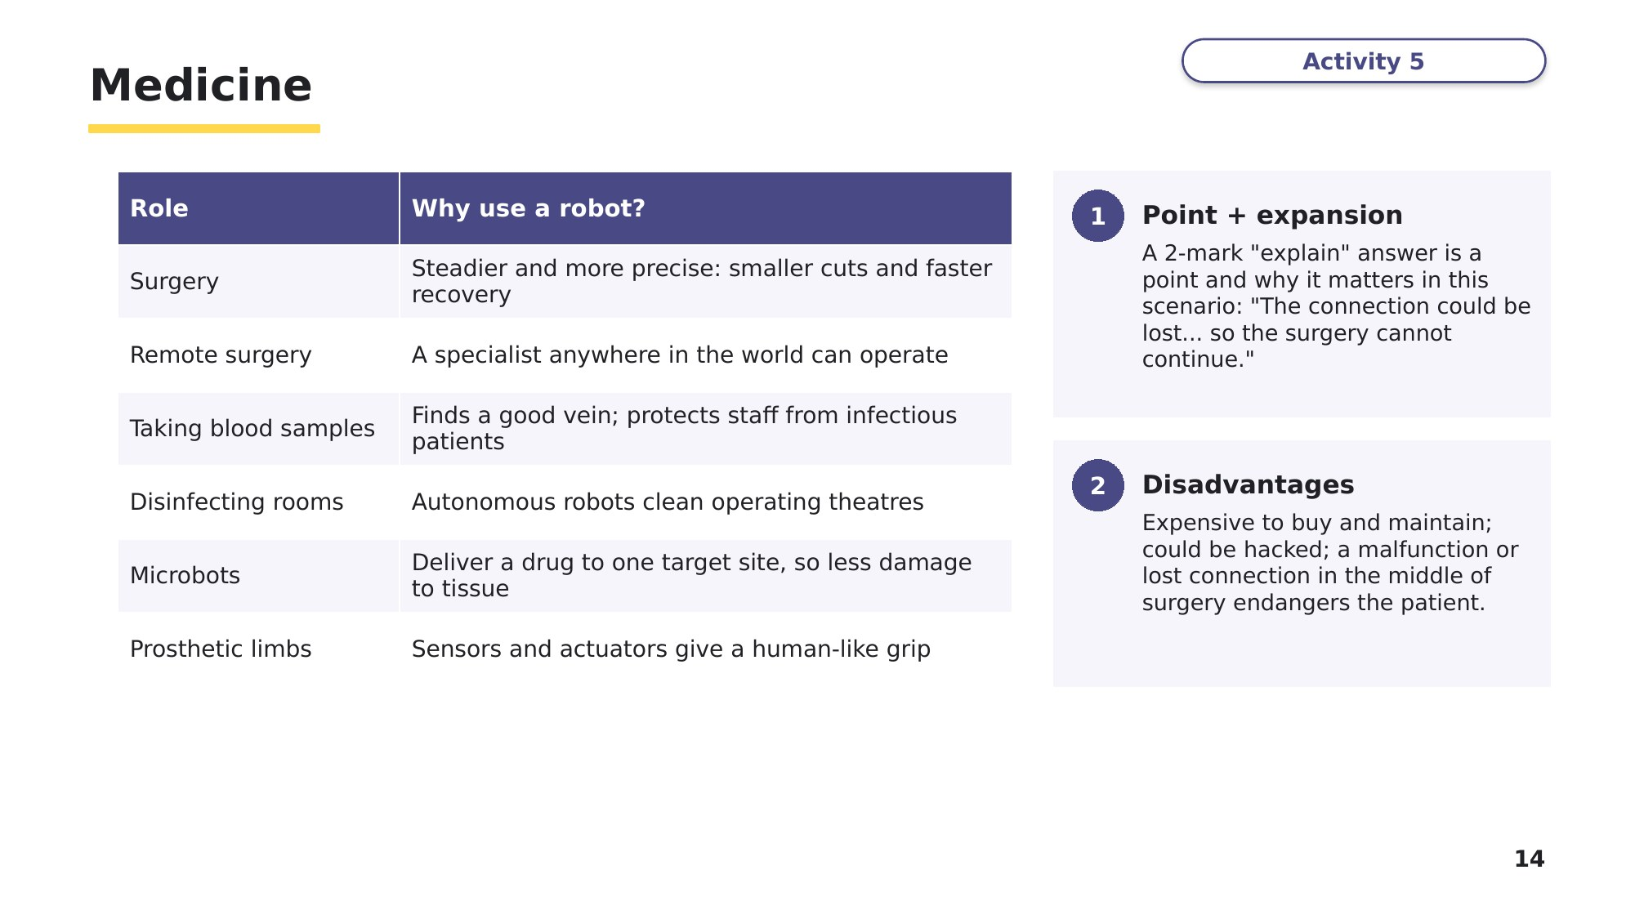
Slide 14 - Medicine
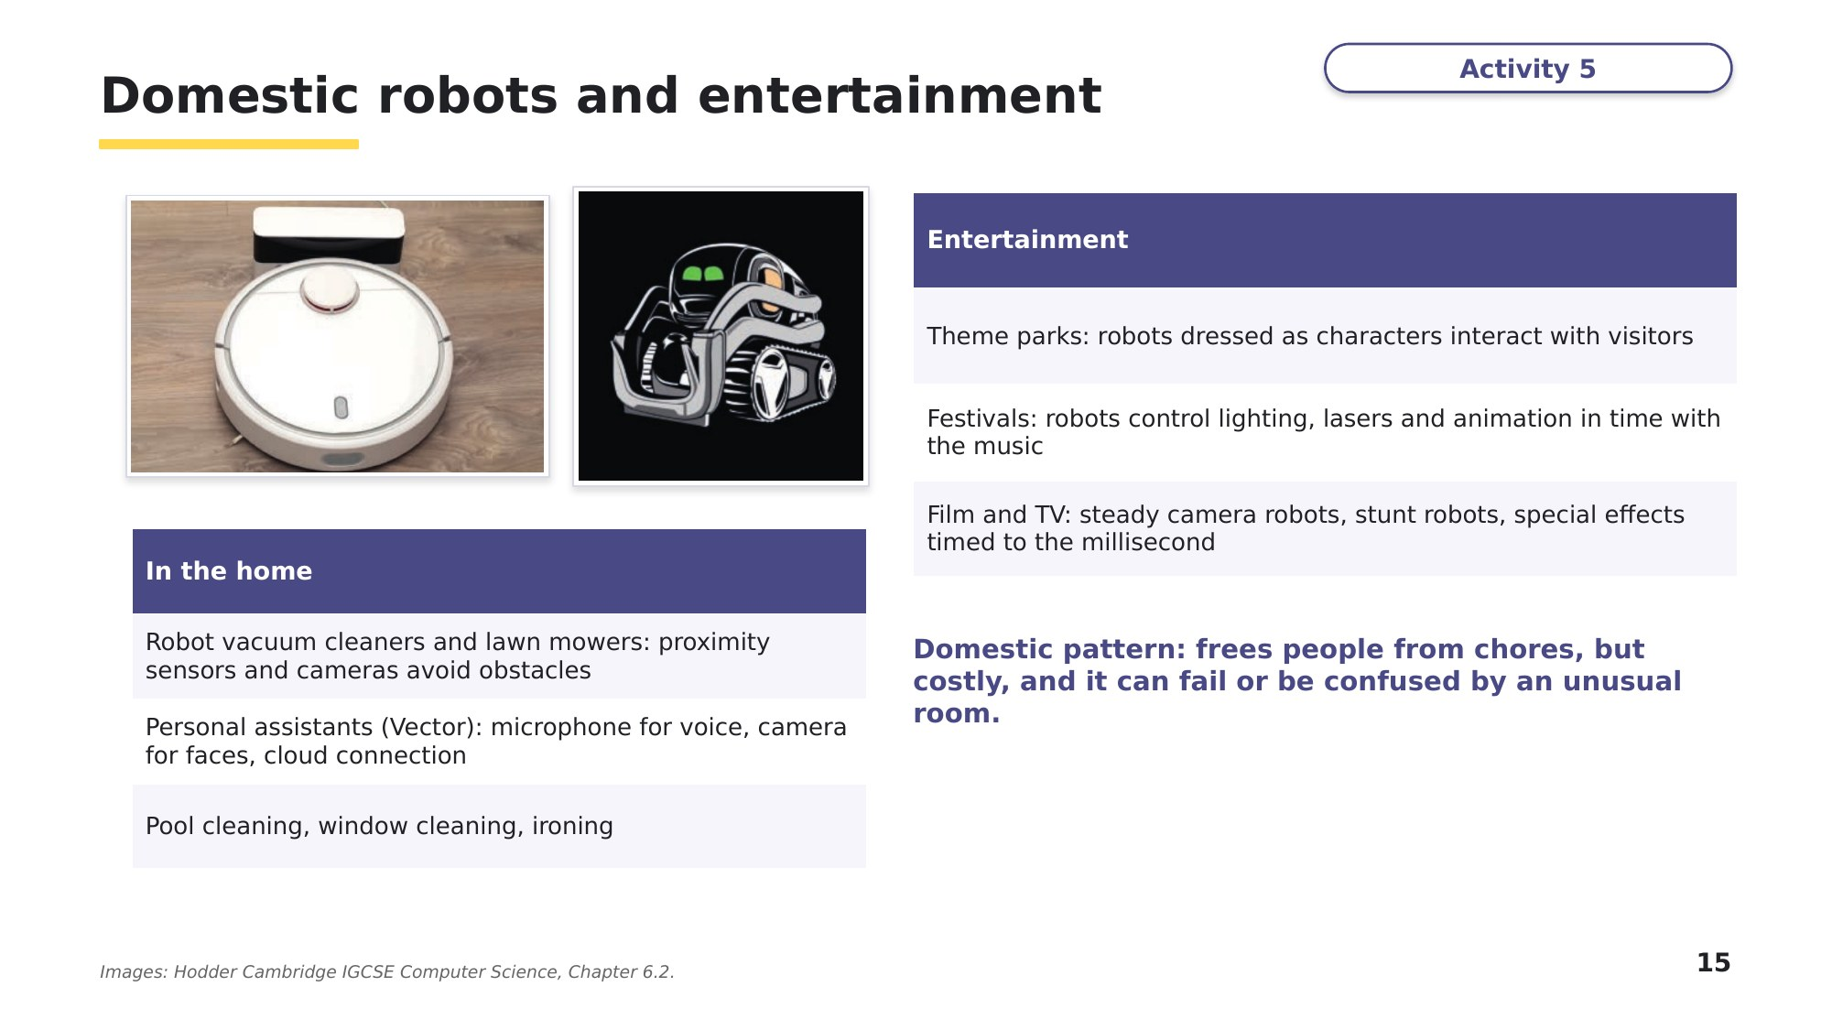
Slide 15 - Domestic robots and entertainment
Task 5 Exam questions: roles, advantages and disadvantages [30 marks]
A company uses robots in its factory to manufacture large pieces of furniture.
(a) Give two advantages to company employees of using robots to manufacture large pieces of furniture. [2]

(b) Give one disadvantage to the company's owners of using robots to manufacture large pieces of furniture. [1]

0478/11 May/June 2023 Q9(b), (c)
A robot is used to move car parts in a factory.
(c) The robot has firmware. State what is meant by firmware. [1]

(d) Interrupts are generated when the robot is operating in the factory. Give two examples of interrupts that may be generated when the robot is in operation. [2]

(e) Give two advantages to the workers in the factory of using robots to move the car parts. [2]

0478/11 May/June 2025 Q8(b)-(d)
A hospital has a robot that is used to perform surgery. A doctor controls the robot from a different location to perform surgery on a patient.
(f) One feature of the robot is that it has electrical components. Give two examples of the electrical components of a robot. [2]

(g) Explain the advantages of using the robot to perform surgery. [4]

(h) Explain one disadvantage of using the robot to perform surgery. [2]

0478/12 May/June 2025 Q5(b)
(i) Complete the table with one use of a robot, one advantage and one disadvantage in each area. [14]
Area | One use of a robot | Advantage | Disadvantage
Transport
Agriculture
Medicine
Domestic (home)
Entertainment
Based on Hodder IGCSE Computer Science, Activities 6.8 and 6.11
Learn Check your Task 5 answers
Only look at this slide once you have finished Task 5. Did you write each advantage for the right person?
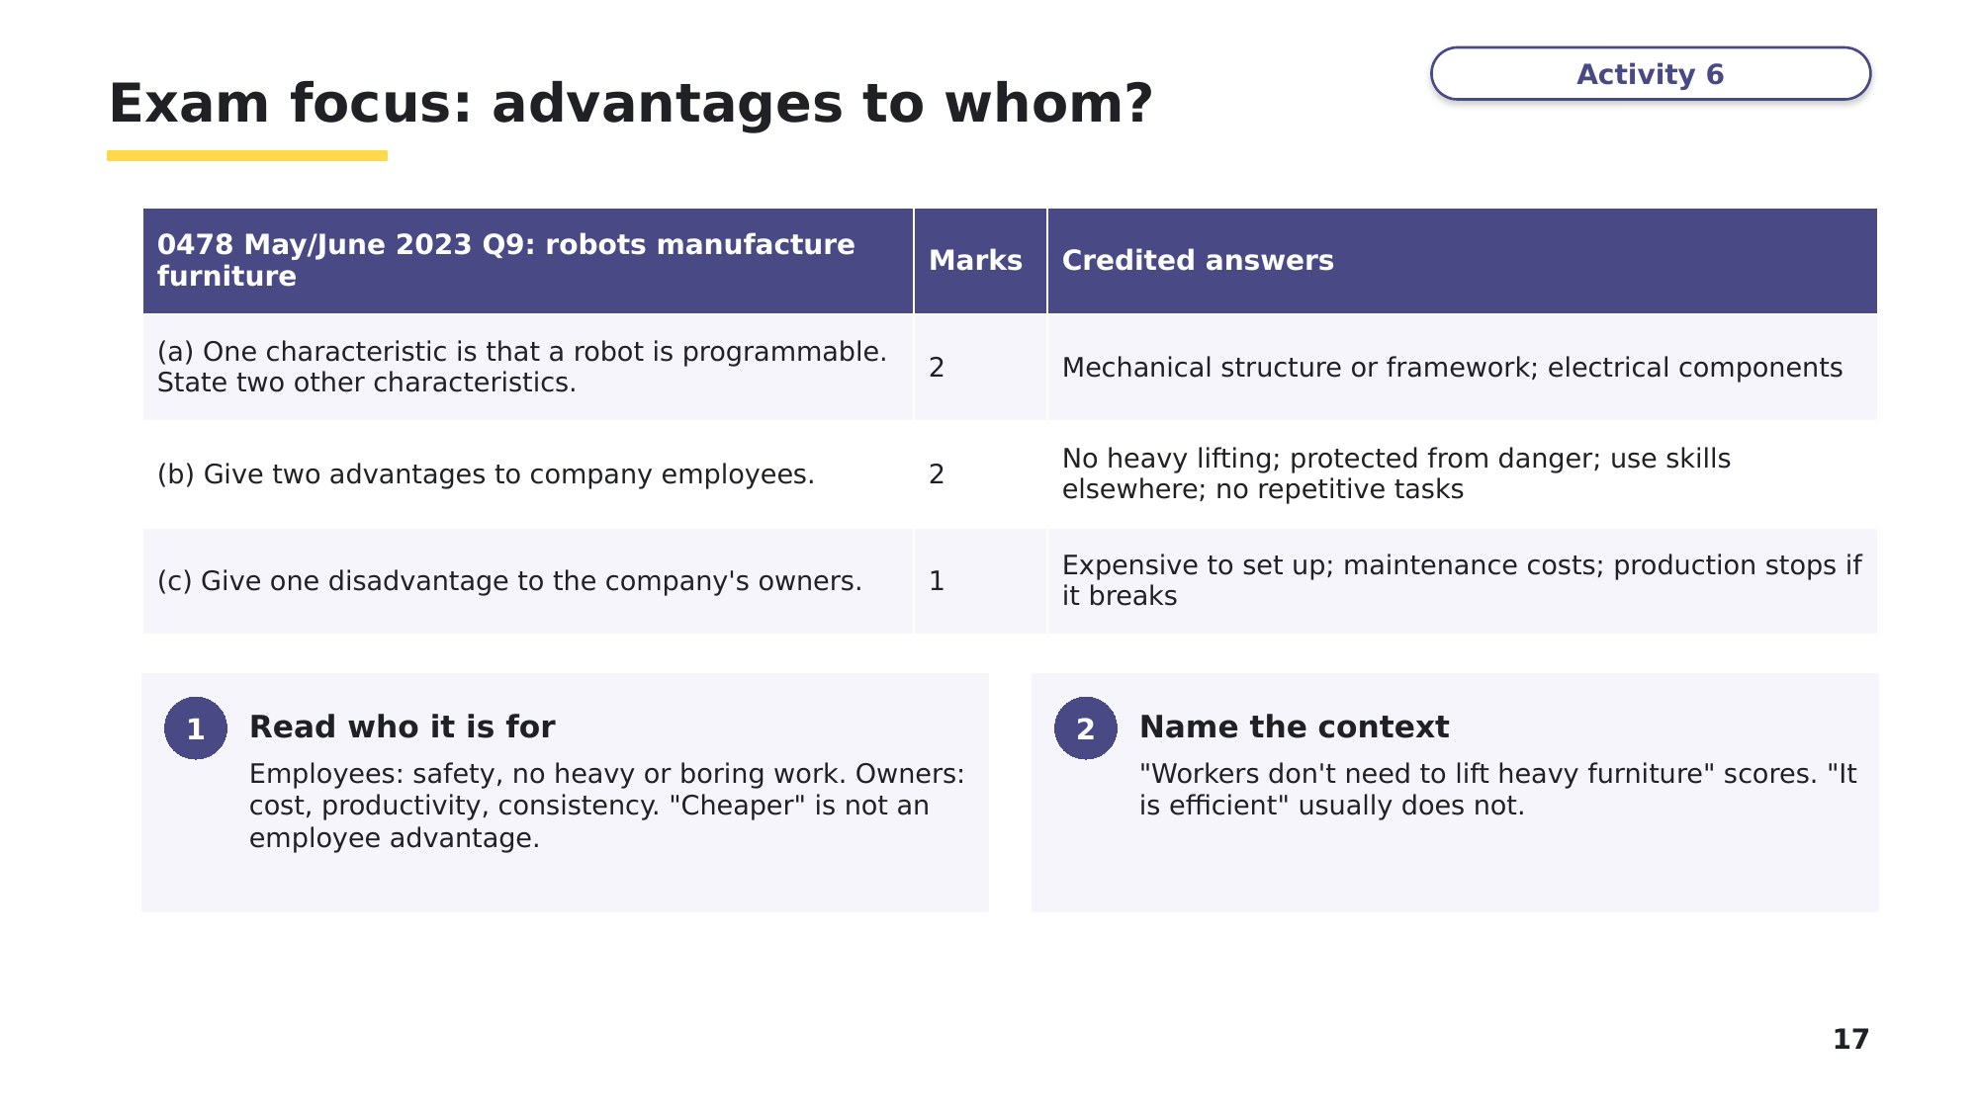
Slide 17 - Exam focus: advantages to whom?
Task 6 Extension: robots in extreme places [12 marks]
Autonomous robots are used in space exploration and in undersea exploration. They have to work in the near vacuum of space or the very high water pressures under the oceans, so they need many sensors and cameras to carry out their tasks.
(a) Undersea robots are used to investigate shipwrecks. Describe how the sensors and cameras could be used to photograph a shipwreck, and the role of the microprocessor and actuators in taking photographs and collecting samples. [5]

(b) A robot sent to Mars needs to move around the surface safely, take photographs and collect soil samples. Describe three uses of the cameras on this autonomous robot. [3]

(c) Describe the advantages and disadvantages of using autonomous robots in undersea and space exploration. [4]

Based on Hodder IGCSE Computer Science, Activity 6.11 Q5
Learn Review
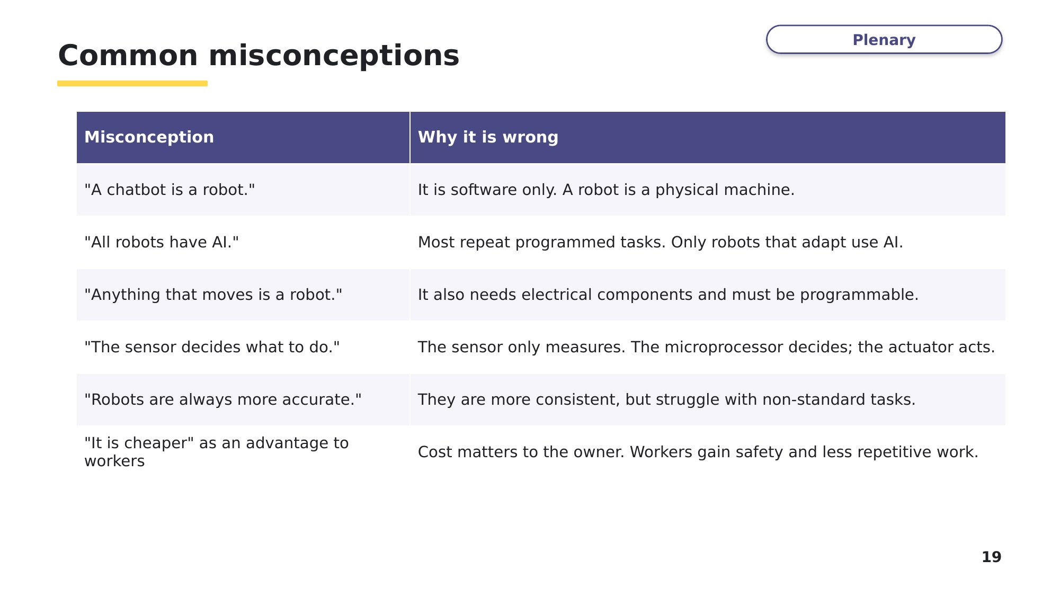
Slide 19 - Common misconceptions
Look back at your Task 1 and Task 2 answers. Correct anything that matches a misconception above.
Exit question [5]
A delivery robot moves along a hospital corridor. It must stop if a person is 1 metre or closer in front of it. Explain how a sensor, a microprocessor and an actuator are used to do this.

